Patrol Lashing Activity
As a patrol gather the required materials. Note that materials can be reused for each project.

Shelter
Materials:
- Tarp
- 4 poles
- 4 tent pegs
- Rope
- Mallet or hammer
As a patrol design a shelter using 4 poles and a tarp. Connect then ends of two poles with a square lashing and 2 poles with a diagonal lashing to make “A” frames to support the tarp. Use rope and two tent pegs to “guy” your structure. Tighten the guylines with a taughtline hitch. The completed structure should shelter one person and include protection from the ground. When it complete have an adult leader review your work. Take down the shelter and proceed to the Flag Pole

Flag Pole
Materials:
- 3 poles
- 3 tent pegs
- Rope
- Mallet or hammer
Use shear lashings to connect the three poles for a minimum height of 15 feet. Install the pole at your camp (tents) with three guylines and tent stakes.

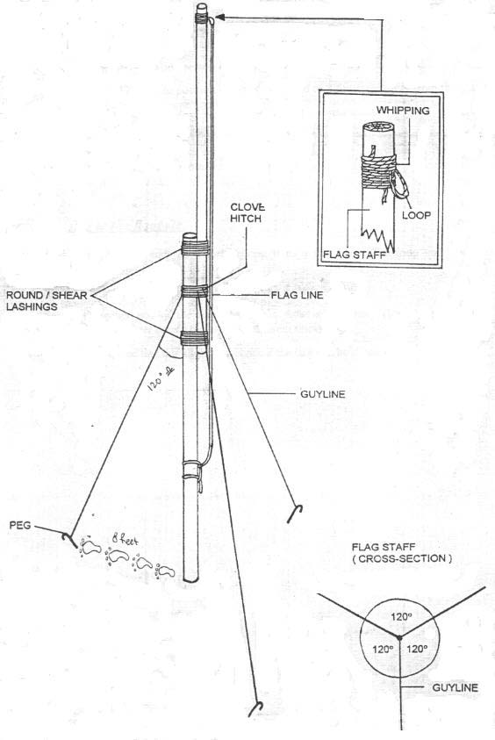
Flag Pole
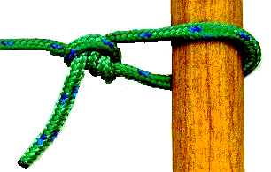
A taughtline hitch.

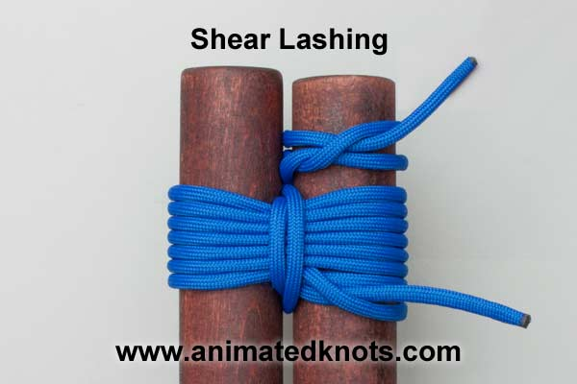

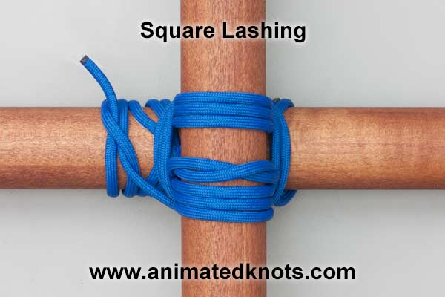
A diagonal Lashing

