Lime Saddle GPS Navigation
Each patrol should have:  - GPS  - Map  - Pencil  Waypoints are marked with flagging and your patrol number. Pick up the flagging as proof you found the correct waypoint. |  | Directions:  - Learn how to navigate to a waypoint using the GPS.  - As a patrol navigate to the #1 waypoint.  - Choose a scout to lead the patrol to the next waypoint using the GPS. Find where you are on the map at the second waypoint and mark the location.  - Choose another scout to navigate to waypoint #3  - Choose another scout to navigate to waypoint #4
Notes | Waypoint # |  | Patrol 1 | Patrol 2 | Patrol 3 | Patrol 4
Start | 1 |  | 001 | 002 | 003 | 004
Find this point on the map | 2 |  | 010 | 017 | 016 | 011
(no flag here) | 3 |  | 099 | 099 | 099 | 099
End | 4 |  | Camp | Camp | Camp | Camp

eTrex GPS Instructions
Power On/Off: Press power button to turn on. Hold power button until screen goes blank to turn off.
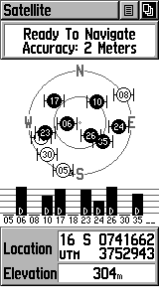  Satellite Page | 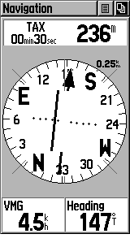  Navigation Page
Selecting Waypoints: Use the page button to go to the Menu Page. Use the down button to select Waypoints, and then press the Enter button. Choose the beginning character of the waypoint, press enter. Select the waypoint from the list, press enter | 