Knot Practice

Materials
- Short lengths of rope.
- Poles

Instructions
As a patrol review the knots and determine who knows how to tie each knot, and who needs to demonstrate the knot for advancement. A good leader should be able to teach scout skills. As a patrol teach each other to tie each knot.

The Knots

Sheet Bend (2nd class)
Use a sheet bend to join two ropes.
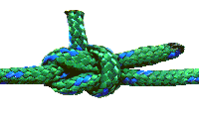

Bowline (2nd Class)
Tie a bowline around your waist.
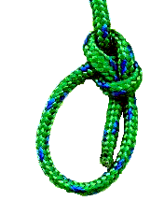

Clove Hitch (1st Class)
Tie a clove hitch around the middle of a pole.
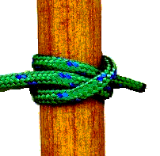

Timber Hitch (1st Class)
Practice tying the timber hitch. Use a timber hitch and a half hitch to secure and drag a pole.
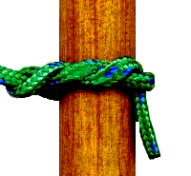

Patrol Competition
A adult leader will call out the name of a knot and the first patrol to have all members successfully tie the know will win the round. The patrol that wins of the most rounds will be declared the overall winner.

Sign off the requirement
If you need these knots for advancement demonstrate the knot to an adult leader and ask them to sign in your book.

