Destination: | Canyon Creek in Trinity Alps Wilderness
Description: | Fairly low elevation (4500’) in the beautiful Trinity Alps. Beautiful creek and majestic granite peaks.
Permits: | Required, but no quota. Pick up at the Weaverville USFS office
Backpacking: | Nice large camp sites above the falls (about 5 miles). Take the Boulder Cr Lakes Turnoff off to the creek. Good day hikes above the falls to Canyon Creek Lakes or Boulder Creek Lakes. Sites on both sides of the creek upstream from trail. Camping at Lower Canyon Creek Lake or Boulder Creek Lakes is possible, but the trail is rough and steep above the falls.
Car Camping: | Ripstein Campground at the trail head. No water, but toilets. Would make a good first night or a base camp for day hikes to nice falls on Canyon Creek. http://www.fs.usda.gov/recarea/stnf/recreation/camping-cabins/recarea/?recid=6533&actid=29
Car Travel | 150 miles from Paradise. A little past Weaverville
Web Sites: | Google Map: https://maps.google.com/maps?q=40.761431,-122.987616&hl=en&num=1&t=m&z=15  USFS Site: http://www.fs.usda.gov/recarea/stnf/recreation/ohv/recarea/?recid=6521&actid=34
Maps: | Trinity Alps Wilderness, Shasta-Trinity NF
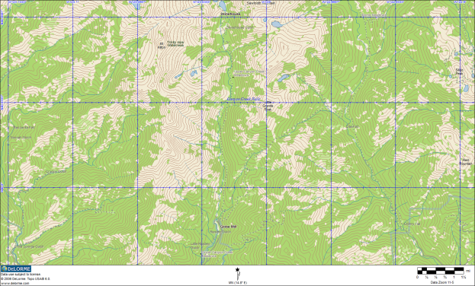
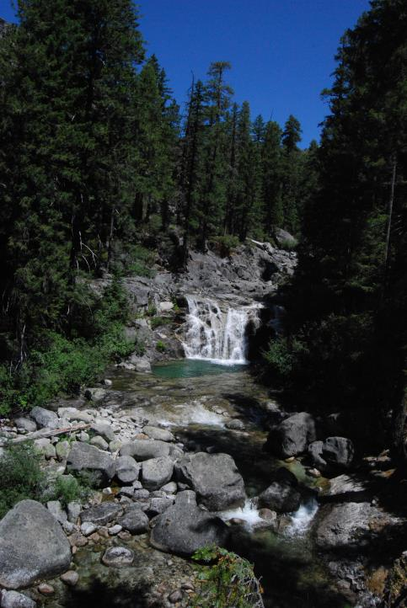
Lower Falls on Canyon Creek

